Nick Forleo

SWENG 505

1. Draw the AOA network and identify the critical path. Also calculate the ES, EF, LS, and LF for each activity:

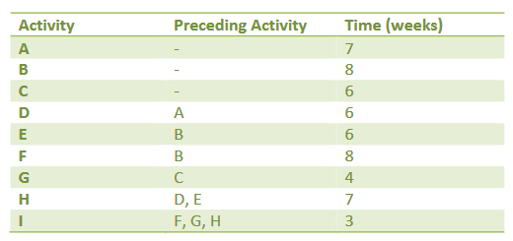

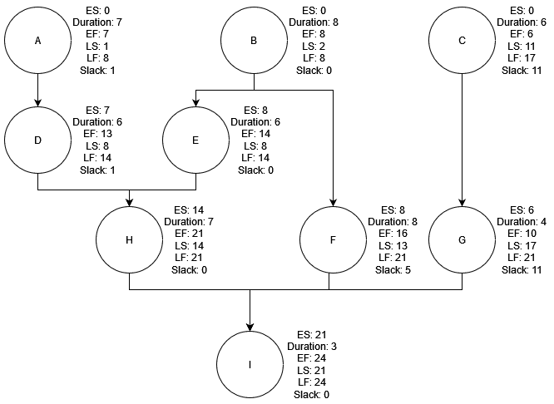

**Critical Path:**  B → E → H → I

1. Draw the network and identify the critical path. Also calculate the ES, EF, LS, and LF for each activity.

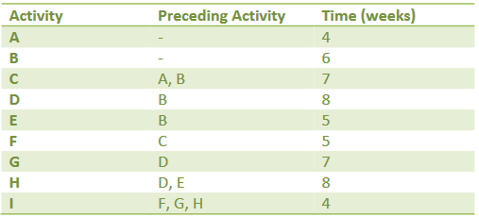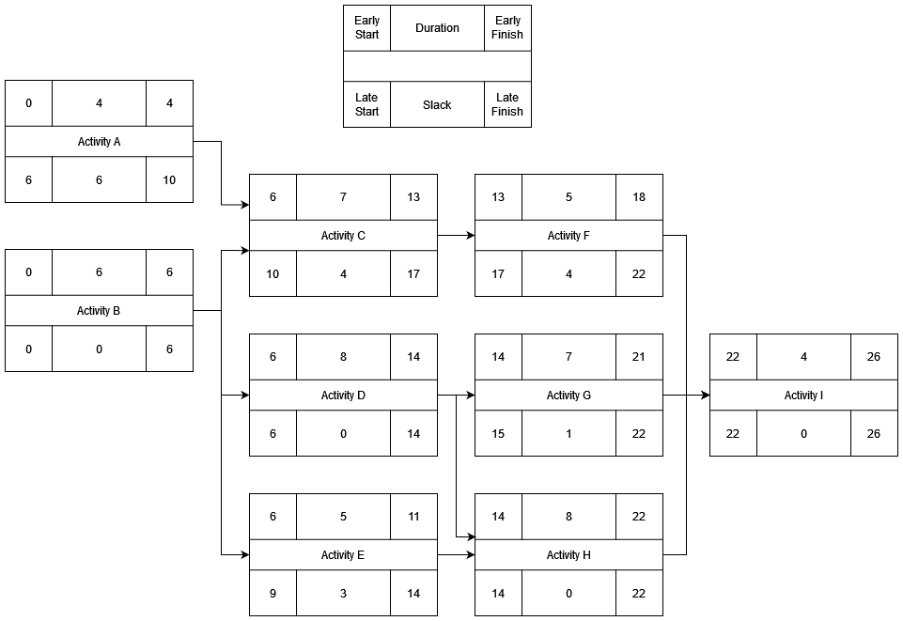

**Critical Path:** B → D → H → I

3) Draw the network and identify the critical path and associated time.

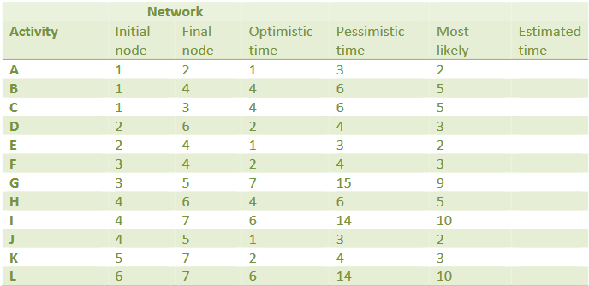

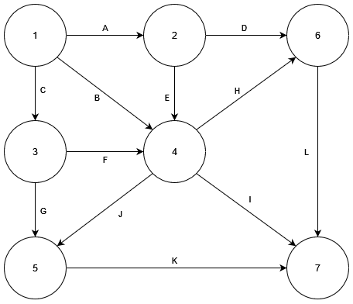

| Activity | Initial Node | Final Node | Optimistic Time | Pess. Time | Most Likely | Est. Time | ES | EF | LS | LF | Slack | Variance |
| --- | --- | --- | --- | --- | --- | --- | --- | --- | --- | --- | --- | --- |
| A | 1 | 2 | 1 | 3 | 2 | 2 | 0 | 2 | 4 | 6 | 4 | 0.11 |
| B | 1 | 4 | 4 | 6 | 5 | 5 | 0 | 5 | 3 | 8 | 3 | 0.11 |
| C | 1 | 3 | 4 | 6 | 5 | 5 | 0 | 5 | 0 | 5 | 0 | 0.11 |
| D | 2 | 6 | 2 | 4 | 3 | 3 | 2 | 5 | 10 | 13 | 8 | 0.11 |
| E | 2 | 4 | 1 | 3 | 2 | 2 | 2 | 4 | 6 | 8 | 4 | 0.11 |
| F | 3 | 4 | 2 | 4 | 3 | 3 | 5 | 8 | 5 | 8 | 0 | 0.11 |
| G | 3 | 5 | 7 | 15 | 9 | 9.67 | 5 | 14.67 | 10.33 | 20 | 5.33 | 1.78 |
| H | 4 | 6 | 4 | 6 | 5 | 5 | 8 | 13 | 8 | 13 | 0 | 0.11 |
| I | 4 | 7 | 6 | 14 | 10 | 10 | 8 | 18 | 13 | 23 | 5 | 1.78 |
| J | 4 | 5 | 1 | 3 | 2 | 2 | 8 | 10 | 18 | 20 | 10 | 0.11 |
| K | 5 | 7 | 2 | 4 | 3 | 3 | 14.67 | 17.67 | 20 | 23 | 5.33 | 0.11 |
| L | 6 | 7 | 6 | 14 | 10 | 10 | 13 | 23 | 13 | 23 | 0 | 1.78 |
| **Critical Path:** C --> F --> H --> L | | | | | | | | | | | | |
|
| Mean: | 23 |  |  |  |  |  |  |  |  |  |  |  |
| Variance: | 2.11 |  |  |  |  |  |  |  |  |  |  |  |
| 68% | 23.76 |  |  |  |  |  |  |  |  |  |  |  |
| 95% | 25.36 |  |  |  |  |  |  |  |  |  |  |  |
| 99% | 26.38 |  |  |  |  |  |  |  |  |  |  |  |